
Human Biology – General Year 11 Task 12 – Unit 2
Name: _________________________________
Assessment type: Test
Conditions:
Period allowed for completion of the task:
- One lesson in class for revision
- One lesson to complete test
Task weighting: 6% of the school mark for Units 1 and 2
Task 12: Test – Pregnancy and Birth (39 marks)
___________________________________________________________________________
Multiple Choice (10 marks)
- The ovary produces
  - Eggs
  - Estrogen
  - Progesterone
  - All of the above

- Where does fertilisation take place if sperm is present?
  - Fallopian tube
  - Uterus
  - Vagina
  - None of the above

- What does testosterone control?
  - Production of sperm
  - Male secondary sexual characteristics
  - Both a and b
  - None of the above

- The menstrual and ovarian cycles, and other features of the human reproductive systems, depend on the _____________ glands for their regulation and control
  - Endocrine
  - Sperm
  - Fallopian
  - Pituitary

- What is thought to help the sperm reach the uterine tubes?
  - Sexual position
  - Timing of sex in relation to the menstrual cycle
  - Muscular contractions of the uterus and the uterine tubes
  - Muscular contractions of the vagina

- What is the average time for an ovarian cycle to complete?
  - 26 days
  - 27 days
  - 28 days
  - 29 days

- A birth, the ovaries of a human female contain about _____________ immature eggs
  - 100 000
  - 200 000
  - 300 000
  - 400 000

- When do ovarian cycles usually resume after pregnancy?
  - After birth is complete
  - A month after birth
  - After breastfeeding of the baby has ceased
  - 4 months after birth

- What is the main organ of the male reproductive system?
  - Testis
  - Penis
  - Scrotum
  - Prostate

- What is the function of seminal fluid?
  - To store the sperm in the epididymis
  - To mature the sperm
  - To make the sperm travel faster
  - To nourish and protect the sperm
Short Answer (20 marks)
- Briefly describe three changes that occur in the mother during pregnancy (3 marks)
____________________________________________________________________________________________________________________________________________________________________________________________________________________________________________________________________________________________________________________________________________________________________________________________________________________________________________________________________________________________________________

- Identify and describe two environmental factors can affect the development of the foetus? (2 marks)
________________________________________________________________________________________________________________________________________________________________________________________________________________________________________________________________________________________________________________________________________________________________________________________________________________________________________________________________________________________________________________________________________________________________________________________________________________________________________________________________________________
- Label the following digrams (8 marks)

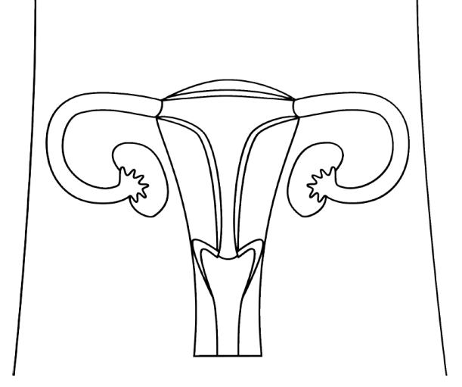

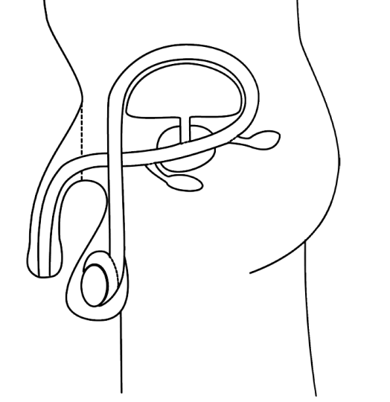

- Complete the following table: (7 marks)

Stage | Time Span (days) | Main Events
Menstruation |  | Uterine bledding, accompanied by shedding of the endometrium
 | 5-12 days | Endometrial repair begins, ovarian follicle development, and uterine lining thickens.
 | 13-15 days
Secretion |  | Secretion of watery mucus, breakdown of unfertilisied egg, corpus luteum developed.
Premenstruation

Extended Answer: (9 marks)
15. Describe the events that take place during:
a) the first stage of labour (3 marks)
b) the second stage of labour (3 marks)
c) the third stage of labour (3 marks)
________________________________________________________________________________________________________________________________________________________________________________________________________________________________________________________________________________________________________________________________________________________________________________________________________________________________________________________________________________________________________________________________________________________________________________________________________________________________________________________________________________________________________________________________________________________________________________________________________________________________________________________________________________________________________________________________________________________________________________________________________________________________________________________________________________________________________________________________________________________________________________________________________________________________________________________________________________________________________________________________________________________________________________________________________________________________________________________________________________________________________________________________________________________________________________________________________________________________________________________________________________________________________________________________________________________________________________________________________________________________________________________________________________________________________________________________________________________________________________________________________________________________________________

